МИНИСТЕРСТВО ОБРАЗОВАНИЯ РЕСПУБЛИКИ БЕЛАРУСЬ

УЧРЕЖДЕНИЕ ОБРАЗОВАНИЯ

“БРЕСТСКИЙ ГОСУДАРСТВЕННЫЙ ТЕХНИЧЕСКИЙ УНИВЕРСИТЕТ”

**ИНТЕЛЕКТУАЛЬНЫЕ ИНФОРМАЦИОННЫЕ ТЕХНОЛОГИИ**

ОТЧЁТ

По лабораторной работе № 8

Выполнил:

Студент группы ИИ-22

Копанчук Е. Р.

Проверил:

Касьяник В.В.

Брест – 2023

Ход работы

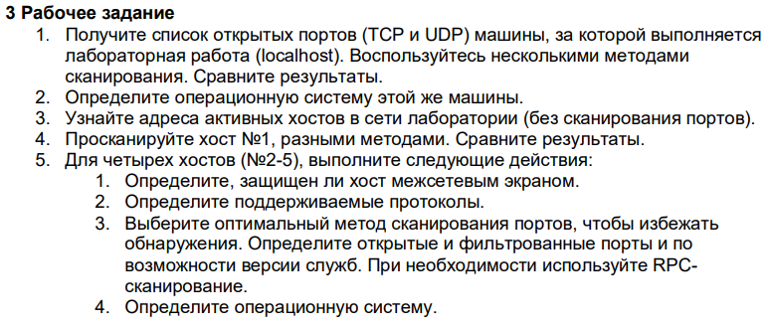

nmap localhost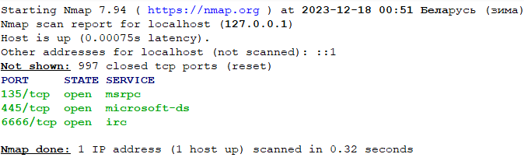

nmap -sU localhost



nmap -O localhost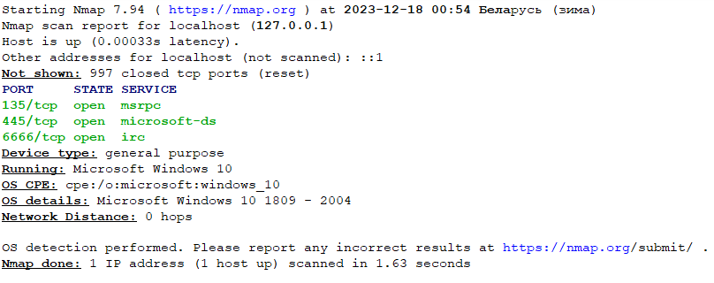

nmap -sn 192.168.0.103

Starting Nmap 7.94 ( https://nmap.org ) at 2023-12-18 09:16 Беларусь (зима)

Nmap scan report for 100.70.53.0  
Nmap scan report for 100.70.53.1  
Nmap scan report for 100.70.53.2  
Nmap scan report for 100.70.53.3  
Nmap scan report for 100.70.53.4  
Nmap scan report for 100.70.53.5  
Nmap done: 256 IP addresses (0 hosts up) scanned in 0.12 seconds

nmap -p 1 100.70.53.64/24

Starting Nmap 7.94 ( https://nmap.org ) at 2023-12-18 09:27 Беларусь (зима)  
Nmap scan report for 100.70.53.3  
Host is up (0.020s latency).  
PORT STATE SERVICE  
1/tcp filtered tcpmux  
MAC Address: 00:00:5E:00:52:13 (Icann, Iana Department)  
Nmap scan report for 100.70.53.4  
Host is up (0.058s latency).  
PORT STATE SERVICE  
1/tcp filtered tcpmux  
MAC Address: 00:00:5E:00:52:13 (Icann, Iana Department)  
Nmap scan report for 100.70.53.17  
Host is up (2.1s latency).  
PORT STATE SERVICE  
1/tcp filtered tcpmux  
MAC Address: 00:00:5E:00:52:13 (Icann, Iana Department)  
Nmap scan report for 100.70.53.30  
Host is up (0.013s latency).  
PORT STATE SERVICE  
1/tcp filtered tcpmux  
MAC Address: 00:00:5E:00:52:13 (Icann, Iana Department)  
Nmap scan report for 100.70.53.31  
Host is up (0.012s latency).  
PORT STATE SERVICE  
1/tcp filtered tcpmux  
MAC Address: 00:00:5E:00:52:13 (Icann, Iana Department)  
Nmap scan report for 100.70.53.69  
Host is up (2.2s latency).  
PORT STATE SERVICE  
1/tcp filtered tcpmux  
MAC Address: 00:00:5E:00:52:13 (Icann, Iana Department)  
Nmap scan report for 100.70.53.76  
Host is up (2.4s latency).  
PORT STATE SERVICE  
1/tcp filtered tcpmux  
MAC Address: 00:00:5E:00:52:13 (Icann, Iana Department)  
Nmap scan report for 100.70.53.8  
Host is up (3.1s latency).  
PORT STATE SERVICE  
1/tcp filtered tcpmux  
MAC Address: 00:00:5E:00:52:13 (Icann, Iana Department)  
Nmap scan report for 100.70.53.114  
Host is up (1.1s latency).  
PORT STATE SERVICE  
1/tcp filtered tcpmux  
MAC Address: 00:00:5E:00:52:13 (Icann, Iana Department)  
Nmap scan report for 100.70.53.183  
Host is up (0.22s latency).  
PORT STATE SERVICE  
1/tcp closed tcpmux  
MAC Address: 26:BE:1A:EC:A6:37 (Unknown)  
Nmap scan report for 100.70.53.195  
Host is up (4.8s latency).  
PORT STATE SERVICE  
1/tcp filtered tcpmux  
MAC Address: 00:00:5E:00:52:13 (Icann, Iana Department)  
Nmap scan report for 100.70.53.226  
Host is up (5.5s latency).  
PORT STATE SERVICE  
1/tcp filtered tcpmux  
MAC Address: 00:00:5E:00:52:13 (Icann, Iana Department)  
Nmap scan report for 100.70.53.252  
Host is up (6.9s latency).  
PORT STATE SERVICE  
1/tcp filtered tcpmux  
MAC Address: 00:00:5E:00:52:13 (Icann, Iana Department)  
Nmap scan report for 100.70.53.64  
Host is up (0.0010s latency).  
PORT STATE SERVICE  
1/tcp closed tcpmux  
Nmap done: 256 IP addresses (14 hosts up) scanned in 32.01 seconds

nmap -p 2-5 100.70.53.64/24

Starting Nmap 7.94 ( https://nmap.org ) at 2023-12-18 09:34 Беларусь (зима)  
RTTVAR has grown to over 2.3 seconds, decreasing to 2.0  
RTTVAR has grown to over 2.3 seconds, decreasing to 2.0  
Nmap scan report for 100.70.53.3  
Host is up (0.015s latency).  
PORT STATE SERVICE  
2/tcp filtered compressnet  
3/tcp filtered compressnet  
4/tcp filtered unknown  
5/tcp filtered rje  
MAC Address: 00:00:5E:00:52:13 (Icann, Iana Department)  
Nmap scan report for 100.70.53.4  
Host is up (0.040s latency).  
PORT STATE SERVICE  
2/tcp filtered compressnet  
3/tcp filtered compressnet  
4/tcp filtered unknown  
5/tcp filtered rje  
MAC Address: 00:00:5E:00:52:13 (Icann, Iana Department)  
Nmap scan report for 100.70.53.30  
Host is up (0.028s latency).  
PORT STATE SERVICE  
2/tcp filtered compressnet  
3/tcp filtered compressnet  
4/tcp filtered unknown  
5/tcp filtered rje  
MAC Address: 00:00:5E:00:52:13 (Icann, Iana Department)  
Nmap scan report for 100.70.53.33  
Host is up (1.3s latency).  
PORT STATE SERVICE  
2/tcp filtered compressnet  
3/tcp filtered compressnet  
4/tcp filtered unknown  
5/tcp filtered rje  
MAC Address: 00:00:5E:00:52:13 (Icann, Iana Department)  
Nmap scan report for 100.70.53.45  
Host is up (0.040s latency).  
PORT STATE SERVICE  
2/tcp filtered compressnet  
3/tcp filtered compressnet  
4/tcp filtered unknown  
5/tcp filtered rje  
MAC Address: 00:00:5E:00:52:13 (Icann, Iana Department)  
Nmap scan report for 100.70.53.47  
Host is up (0.077s latency).  
PORT STATE SERVICE  
2/tcp filtered compressnet  
3/tcp filtered compressnet  
4/tcp filtered unknown  
5/tcp filtered rje  
MAC Address: 00:00:5E:00:52:13 (Icann, Iana Department)  
Nmap scan report for 100.70.53.54  
Host is up (0.043s latency).  
PORT STATE SERVICE  
2/tcp filtered compressnet  
3/tcp filtered compressnet  
4/tcp filtered unknown  
5/tcp filtered rje  
MAC Address: 00:00:5E:00:52:13 (Icann, Iana Department)  
Nmap scan report for 100.70.53.83  
Host is up (0.012s latency).  
PORT STATE SERVICE  
2/tcp filtered compressnet  
3/tcp filtered compressnet  
4/tcp filtered unknown  
5/tcp filtered rje  
MAC Address: 00:00:5E:00:52:13 (Icann, Iana Department)  
Nmap scan report for 100.70.53.163  
Host is up (4.3s latency).  
PORT STATE SERVICE  
2/tcp filtered compressnet  
3/tcp filtered compressnet  
4/tcp filtered unknown  
5/tcp filtered rje  
MAC Address: 00:00:5E:00:52:13 (Icann, Iana Department)  
Nmap scan report for 100.70.53.237  
Host is up (0.019s latency).  
PORT STATE SERVICE  
2/tcp filtered compressnet  
3/tcp filtered compressnet  
4/tcp filtered unknown  
5/tcp filtered rje  
MAC Address: 00:00:5E:00:52:13 (Icann, Iana Department)  
Nmap scan report for 100.70.53.64  
Host is up (0.00067s latency).  
PORT STATE SERVICE  
2/tcp closed compressnet  
3/tcp closed compressnet  
4/tcp closed unknown  
5/tcp closed rje  
Nmap done: 256 IP addresses (11 hosts up) scanned in 31.86 seconds

nmap -p 2-5 -O 100.70.53.64/24

Starting Nmap 7.94 ( https://nmap.org ) at 2023-12-18 09:40 Беларусь (зима)  
RTTVAR has grown to over 2.3 seconds, decreasing to 2.0  
RTTVAR has grown to over 2.3 seconds, decreasing to 2.0  
RTTVAR has grown to over 2.3 seconds, decreasing to 2.0  
RTTVAR has grown to over 2.3 seconds, decreasing to 2.0  
RTTVAR has grown to over 2.3 seconds, decreasing to 2.0  
Nmap scan report for 100.70.53.3  
Host is up (0.017s latency).  
PORT STATE SERVICE  
2/tcp filtered compressnet  
3/tcp filtered compressnet  
4/tcp filtered unknown  
5/tcp filtered rje  
MAC Address: 00:00:5E:00:52:13 (Icann, Iana Department)  
Too many fingerprints match this host to give specific OS details  
Network Distance: 1 hop  
Nmap scan report for 100.70.53.4  
Host is up (0.037s latency).  
PORT STATE SERVICE  
2/tcp filtered compressnet  
3/tcp filtered compressnet  
4/tcp filtered unknown  
5/tcp filtered rje  
MAC Address: 00:00:5E:00:52:13 (Icann, Iana Department)  
Too many fingerprints match this host to give specific OS details  
Network Distance: 1 hop  
Nmap scan report for 100.70.53.33  
Host is up (1.3s latency).  
PORT STATE SERVICE  
2/tcp filtered compressnet  
3/tcp filtered compressnet  
4/tcp filtered unknown  
5/tcp filtered rje  
MAC Address: 00:00:5E:00:52:13 (Icann, Iana Department)  
Too many fingerprints match this host to give specific OS details  
Network Distance: 1 hop  
Nmap scan report for 100.70.53.43  
Host is up (0.011s latency).  
PORT STATE SERVICE  
2/tcp filtered compressnet  
3/tcp filtered compressnet  
4/tcp filtered unknown  
5/tcp filtered rje  
MAC Address: 00:00:5E:00:52:13 (Icann, Iana Department)  
Too many fingerprints match this host to give specific OS details  
Network Distance: 1 hop  
Nmap scan report for 100.70.53.47  
Host is up (2.7s latency).  
PORT STATE SERVICE  
2/tcp filtered compressnet  
3/tcp filtered compressnet  
4/tcp filtered unknown  
5/tcp filtered rje  
MAC Address: 00:00:5E:00:52:13 (Icann, Iana Department)  
Too many fingerprints match this host to give specific OS details  
Network Distance: 1 hop  
Nmap scan report for 100.70.53.51  
Host is up (2.7s latency).  
PORT STATE SERVICE  
2/tcp filtered compressnet  
3/tcp filtered compressnet  
4/tcp filtered unknown  
5/tcp filtered rje  
MAC Address: 00:00:5E:00:52:13 (Icann, Iana Department)  
Too many fingerprints match this host to give specific OS details  
Network Distance: 1 hop  
Nmap scan report for 100.70.53.78  
Host is up (3.4s latency).  
PORT STATE SERVICE  
2/tcp filtered compressnet  
3/tcp filtered compressnet  
4/tcp filtered unknown  
5/tcp filtered rje  
MAC Address: 00:00:5E:00:52:13 (Icann, Iana Department)  
Too many fingerprints match this host to give specific OS details  
Network Distance: 1 hop  
Nmap scan report for 100.70.53.81  
Host is up (0.012s latency).  
PORT STATE SERVICE  
2/tcp filtered compressnet  
3/tcp filtered compressnet  
4/tcp filtered unknown  
5/tcp filtered rje  
MAC Address: 00:00:5E:00:52:13 (Icann, Iana Department)  
Too many fingerprints match this host to give specific OS details  
Network Distance: 1 hop  
Nmap scan report for 100.70.53.101  
Host is up (0.038s latency).  
PORT STATE SERVICE  
2/tcp filtered compressnet  
3/tcp filtered compressnet  
4/tcp filtered unknown  
5/tcp filtered rje  
MAC Address: 00:00:5E:00:52:13 (Icann, Iana Department)  
Too many fingerprints match this host to give specific OS details  
Network Distance: 1 hop  
Nmap scan report for 100.70.53.118  
Host is up (1.6s latency).  
PORT STATE SERVICE  
2/tcp filtered compressnet  
3/tcp filtered compressnet  
4/tcp filtered unknown  
5/tcp filtered rje  
MAC Address: 00:00:5E:00:52:13 (Icann, Iana Department)  
Too many fingerprints match this host to give specific OS details  
Network Distance: 1 hop  
Nmap scan report for 100.70.53.135  
Host is up (0.047s latency).  
PORT STATE SERVICE  
2/tcp filtered compressnet  
3/tcp filtered compressnet  
4/tcp filtered unknown  
5/tcp filtered rje  
MAC Address: 00:00:5E:00:52:13 (Icann, Iana Department)  
Too many fingerprints match this host to give specific OS details  
Network Distance: 1 hop  
Nmap scan report for 100.70.53.161  
Host is up (6.5s latency).  
PORT STATE SERVICE  
2/tcp filtered compressnet  
3/tcp filtered compressnet  
4/tcp filtered unknown  
5/tcp filtered rje  
MAC Address: 00:00:5E:00:52:13 (Icann, Iana Department)  
Too many fingerprints match this host to give specific OS details  
Network Distance: 1 hop  
Nmap scan report for 100.70.53.162  
Host is up (3.8s latency).  
PORT STATE SERVICE  
2/tcp filtered compressnet  
3/tcp filtered compressnet  
4/tcp filtered unknown  
5/tcp filtered rje  
MAC Address: 00:00:5E:00:52:13 (Icann, Iana Department)  
Too many fingerprints match this host to give specific OS details  
Network Distance: 1 hop  
Nmap scan report for 100.70.53.64  
Host is up (0.00053s latency).  
PORT STATE SERVICE  
2/tcp closed compressnet  
3/tcp closed compressnet  
4/tcp closed unknown  
5/tcp closed rje  
Device type: general purpose  
Running: Microsoft Windows 10|2012|7|8.1|2008|2022|11  
OS CPE: cpe:/o:microsoft:windows_10 cpe:/o:microsoft:windows_server_2012:r2 cpe:/o:microsoft:windows_7 cpe:/o:microsoft:windows_8.1:r1 cpe:/o:microsoft:windows_server_2008:r2 cpe:/o:microsoft:windows_server_2022  
Too many fingerprints match this host to give specific OS details  
Network Distance: 0 hops  
OS detection performed. Please report any incorrect results at https://nmap.org/submit/ .  
Nmap done: 256 IP addresses (14 hosts up) scanned in 404.90 seconds